|  |  |
| --- | --- |
| CKE - Modify PO Report - 88677 | Maintenance Connection Inc. Logo Image |
| Installation Instructions |  |

## Website update

Place: **_rpt_PO1_CKE.asp**

In:

**~\Maintenance Connection\mc_iis\modules\purchaseorder\**

Then update the report settings to use the new file:

First go to:

1. Purchase Order
2. Report
3. Setup

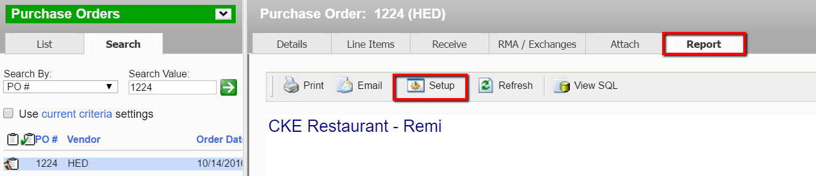

Then change the report file setting in advanced:

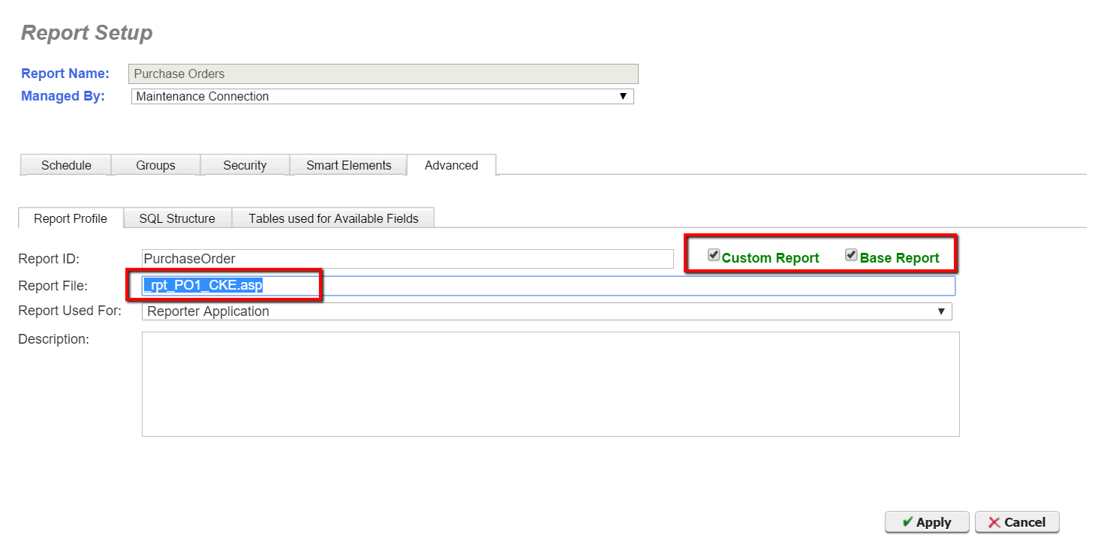

And then apply the changes.

Make sure you empty the browser cache in order to use the new report.